**Experiment 2:-** Design an LED Chaser

**Circuit Diagram:-**



***Circuit with 4 resistors***

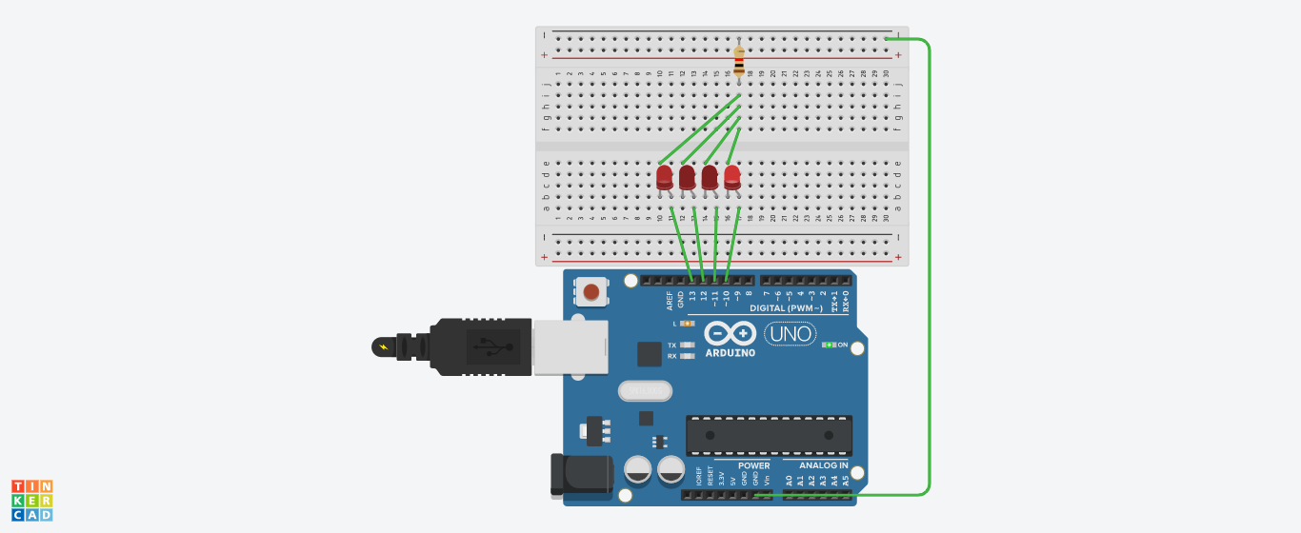

***Circuit with 1 resistor***

**Theory**

**Concept Used:** The task of making an LED chaser has been realized by using the concept of a Switch (ON/OFF) and looping. The Arduino is used as a power source as well as a switch. Firstly, the first two LEDS are switched ‘ON’. After some milliseconds the 1st LED is switched ‘OFF’ and the LED succeeding the 2nd LED is switched ‘ON’ simultaneously. So, the LEDs glow in pairs .The process continues as a chain which gives a chaser effect. The output is realized with the help of looping to decrease the coding work load. The last LED of the chain glows with the 1st as a pair.

* In a series circuit, voltage gets divided and in a parallel circuit, current gets divided but voltage remains same.
* **OHM’s Law:** Ohm’s law states that the current through a conductor between two points is directly proportional to the voltage across two points provided that the temperature remains constant.

V=IR

This is used to determine the value of the resistor suitable for the

circuit thus preventing the LED from burning out.

* **Kirchoff’s Current Law :** The total current entering the node is equal to the total current leaving the node.

**Learning & Observations:** I learned how to make an LED Chaser with looping by using Arduino as a power source and breadboard. I also learned how to make the circuit with the help of 4 resistors or 1 resistor. The observation made was that the LEDs glow in pairs forming a chain of chaser lights.

**Problems & Troubleshooting:** The problem faced by me was that the last LED did not glow with the first LED of the series. The problem was resolved by putting an if statement within the for loop.

**Precautions:**

* The wires and pins should be inserted properly.
* The LED’s should be checked using a Multimeter before use.
* The anode should be connected to the power supply and cathode to the ground.
* The LED should be connected to a resistor to prevent it from any damage.
* The wire should be continuous(check it using a multimeter), otherwise circuit won’t work.
* Both the terminals of LEDs should not be in holes connected to each other.

**Learning Outcomes:** I learned how to make an LED Flasher with the help of Arduino using looping and breadboard. I also learned how to make parallel circuits on breadboard.